**Frequently Asked Questions (FAQs)**

**Who will conduct the election?**

The Executive Director of the Personnel Appeals Board is supervising the conduct of the

Members of the Board's staff (PAB agents). The PAB will certify the election results.

**Who is eligible to vote in the election?**

Every permanent employee of GAO identified in the unit on the payroll for the period ending September 5, 2025.

Excluded are otherwise eligible employees who resign, retire or are subject to removal before September 30, 2025.

**When will the election be held?**

Eligible GAO staff will receive and cast their mail ballots between September 30, 2025, and October 21, 2025. All ballots must be received by the PAB on October 21, 2025, to be counted.

**Where will the election be held?**

The election will be by mail ballots only.

**Is this a secret process?**

Yes. You will mark your ballot in private and deposit the folded, unsigned ballot in a secure envelope and place it in the larger addressed and prepaid envelope and mail back to the address listed on the envelope. Any ballot that contains a signature or any other identifying mark will be voided.

**Will ballots received by mail be secret?**

Yes. Ballots will be mailed to a U.S. Post Office box that will only be accessible to a Board staff member. Each time the staff member empties the Post Office box, he/she will return to the Board's offices, secure the secret ballot envelopes in a large manila envelope, sign his/her name over the envelope seal, and lock the envelope in a file cabinet. At the close of the election on October 21st, the manila envelopes will be transported to the PAB’s Conference room in GAO Headquarters. Board staff will open the sealed manila envelopes in the presence of the observers, remove the ballots from the secret ballot envelopes and begin to tally the votes.

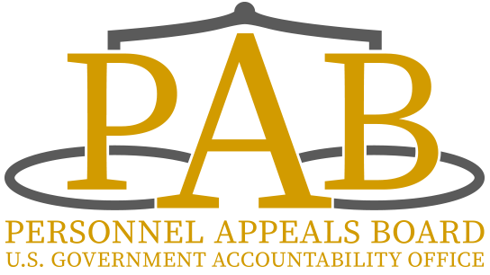

**What if I don't receive a ballot in the mall?**

If you have not received a ballot by October 7, 2025, please contact the Clerk of the Board at 202-512-6137 or [pab@gao.gov](mailto:pab@gao.gov).

**What will be on the ballot?**

You will be asked to answer "Yes" or "No" to a single question: "Do you wish to be represented for the purpose of collective bargaining under the provisions of the Government Accountability Office Personnel Act of 1980 in the proposed unit by the following GAO Employees Organization, IFPTE?

**Other than staff conducting the election count, who will be present in the PAB Suite?**

Each party, GAO and the IFPTE, is entitled to have an equal number of observers in the room, all of whom will be wearing identification tags.

**Can the observers participate in the election process?**

The observers will have the right to challenge voters whom they have good cause to believe are not eligible to vote in the election.

**Can I still vote if my eligibility is challenged?**

You will be permitted to vote, mark your ballot, and mail it. At the end of the election, the challenged ballots will be reviewed by Board officials and observers. If, after review, it is determined that you are eligible to vote in the election then your ballot will be counted during the tally of the ballots.

**I am leaving GAO in September. Will I be able to vote before my departure?**

No. If you are not employed by GAO on September 30, 2025, you may not vote.

**When will the ballots be counted?**

On October 23, 2025, at 11:30 a.m. EST in the PAB Conference Room. Observers for GAO and the Union will be present for the count.

**When will the results of the election be available?**

The Board's Executive Director will announce a tally of the ballots to the observers from GAO and IFPTE upon completion of the counting of all the ballots. PAB will certify the election results.

**What if I have additional questions about the process?**

You may call (202-512-6137) or email the Clerk of the Board at [pab@gao.gov](mailto:pab@gao.gov).